**SHUSA**

**RISK APPETITE STATEMENT**



**METRIC DEFINITION**

**2016 CALIBRATION PERIOD**

|  |  |
| --- | --- |
|  |  |

*Book Perimeter: Balance Sheet Management*

*Risk Type: Liquidity Risk*

*Risk Metric: MVE 100 UP/DOWN shock sensitivity*

|  |  |
| --- | --- |
| **Owner** | ALCO (delegated on Treasury) |
| **1st Line of Defense Area** | **Treasury Department**  Responsibility: Management and strategy implementation |
| **2nd Line of Defense Area** | **Market Risk Department**  Responsibility: Official Report |
| **Description** | *The metric measures the worst exposure in percentage terms over the Market Value of the Equity after applying a parallel shock along the curve from 100 down up to 100 up basis points. The Market value of equity (MVE) is determined as the difference between the market value of assets and liabilities less equity and Off-Balance Sheet exposures.*  *As interest rates rise/fall the MVE will rise and fall accordingly and the sensitivity of this value to those changes is critical to understand the risk exposure of the bank to interest rates.* |
| **Purpose** | *The MVE is an appropriate metric to measure the interest risk exposure through a full revaluation of all on and off balance sheet products interest rate sensitivity.*  *Through the control of this metric is possible to mitigate negative impacts on the economic value of SHUSA balance-sheet that can be generated by adverse market conditions and interest rate shocks that affect the structural position because of maturity mismatch between asset and liabilities.*  *The purpose of the metric is to provide information in terms of risk exposure from a long term perspective and decisions in terms of strategies for positioning the balance-sheet and managing the mismatch between asset and liabilities.* |
| **Limit** | *MVE +/- 100 bps: -7%, for all the exposure between +/-100 shocks.*  *NOTE: The limit MVE sensitivity exposure to interest rate changes from dollar amount to percentage over the base value.* |
| **Limit Justification** | *As of February 28th 2016, the MVE is $19.4bn, which means that the RAS level represents 6.3% of the MVE.*  *The average of the negative exposure in the last five years for the upside and downside shock up to the 200 bps shock level have been $450mm. If we consider also the model deficiencies under stress conditions for prepayments with a 50% of over or underestimation, as well as for Beta shocks higher or lower than 50%, there is an added exposure that can go up to $600mm.*  *Both, the historical exposure and stress conditions totalized a exposure of $1.05bn, which is just $320mm below the RTS level. This room is enough to manage under acceptable levels, market factors that can extend duration in the asset side.* |
| **Calculation of the metric** | *MVE is dependent on a number of assumptions that include: interest rate characteristics of deposits, non-maturing assets/liabilities and the optionality of loans. All deposits without explicit maturities such as DDA, Savings and MMDA type accounts are subject to call risk. Market Risk will annually calibrate and submit to the ALCO and Model Risk Management non maturity asset and liability durations and the model calibrations.*  *MVE measures should incorporate all balance sheet and off-balance sheet risks that can be reasonably quantified so as to produce a single risk metric for SHUSA. On a quarterly basis such risk measures should be produced for SHUSA in order to have a fair basis of comparison for regulatory reporting.*  *Optionality risk should be periodically monitored through a combination of back-tests and shocks. Prepayment models should be monthly shocked in +/- 10% and 50% of speed scenarios to calibrate reliance on model assumptions, or market conditions varying over time.* |
| **Availability** | *A range from 25th to 27h business day of every month, if there is no data and technology issues.*  *The late delivery is explained by the multiple entity process related to the IRR measurement, including SBNA, SC and SHUSA Consolidated portfolios. By the middle of the year is expected that BSI, BSPR and SIS are added to this process. The major constraints relies on SC portfolio reconciliation against GL that happens by the 13 business day of every month, conditioning the time assigned to process, validate, analyze and report the IRR metrics.* |

*Book Perimeter: Balance Sheet Management*

*Risk Type: Liquidity Risk*

*Risk Metric: NII 100 UP/DOWN shock sensitivity*

|  |  |
| --- | --- |
| **Owner** | ALCO (delegated on Treasury) |
| **1st Line of Defense Area** | **Treasury Department**  Responsibility: Management and strategy implementation |
| **2nd Line of Defense Area** | **Market Risk Department**  Responsibility: Official Report |
| **Description of Metric** | *The metric measures the difference between the Net Interest Income base case and Net Interest Income results after an up/down shock of 100 basis points applied along the curve. The Net Interest Income (NII) defines the difference between the interest income and interest expenses.*  *As interest rates rise/fall the NII will rise and fall accordingly and the sensitivity of this value to those changes is critical to understand the risk exposure of the bank to interest rates.* |
| **Why this metric?** | *The NII sensitivity is an appropriate metric to measure the interest risk exposure through the projection of interest income in the next 12 months of all on and off balance sheet products interest rate sensitivity.*  *Through the control of this metric is possible to mitigate negative impacts in the net interest income of SHUSA balance-sheet that can be generated by adverse market conditions and interest rate shocks that affect the structural position because of repricing, reinvestment and refinancing due to mismatch between asset and liabilities.*  *The purpose of the metric is to provide information in terms of risk exposure from a short term perspective and decisions in terms of strategies for positioning the balance-sheet and managing the mismatch between asset and liabilities.* |
| **Limit** | *MVE +/- 100 bps: -3.5%, for all the exposure between +/-100 shocks.*  *The limit NII sensitivity exposure to interest rate changes is changing from dollar amount to percentage over the base value.* |
| **Limit Justification** | *As of February 28th 2016, the NII projection is $6.0bn, which means that the RAS level represents 2.3% of the NII.*  *Stress conditions also contribute to determine the most reliable level for RTS. A 50% lower customer elasticity would impact negatively with $60mm NII and Higher stability could penalize it by $35mm. The historical exposure of NII for SHUSA has been $80mm approximately, which make the $160mm a comfortable zone having stress conditions internalized.* |
| **Calculation of the metric** | *The NII shock and its base Net Interest Income projection are subject to a complex set of assumptions and models. These models and assumptions are subject to SHUSA’s Model Risk Governance.*  *Market Risk Department, as model owner and first line of defense in Model Risk Management, is responsible for documenting all model assumptions and submitting them for internal validation and approval by Model Risk Committee.*  *On a regular basis (see Section Reporting Framework below), the major risks stemming from these assumptions should be identified and reported to the ALCO along with periodic quantification of the risks. These include risk from, but not limited to: prepayments, pricing spread, non-maturity deposit betas and durations and other factors.* |
| **Availability** | *A range from 25th to 27h business day of every month, if there is no data and technology issues.*  *The late delivery is explained by the multiple entity process related to the IRR measurement, including SBNA, SC and SHUSA Consolidated portfolios. By the middle of the year is expected that BSI, BSPR and SIS are added to this process. The major constraints relies on SC portfolio reconciliation against GL that happens by the 13 business day of every month, conditioning the time assigned to process, validate, analyze and report the IRR metrics.* |

**MVE & NII HISTORICAL DATA**

**Santander Bank NA**



**SHUSA Consolidated (SHUSA PO + SBNA + SC)**



*Book Perimeter: Balance Sheet Management*

*Risk Type: Liquidity Risk*

*Risk Metric: Structural Funding Ratio (SFR)*

|  |  |
| --- | --- |
| **Owner** | ALCO (delegated on Treasury) |
| **1st Line of Defense Area** | **Treasury Department**  Responsibility: Management and strategy implementation |
| **2nd Line of Defense Area** | **Market Risk Department**  Responsibility: Official Report |
| **Description** | *This metric measures the amount of structural source of funds that are currently funding long term assets.*  *The Santander’s structural funding is a critical component of the balance sheet once guarantees the capacity of the institution to keep an amount of funds that will not represent an obligation to commit in the short term period, but instead an obligation that has been either allocated in fixed/structural assets or invested in long term assets.* |
| **Purpose** | *The SFR is a good metric to monitor once compiled in one metric all the balance sheet components related to stable source of funds.*  *This metric looks for mitigating the concentration on short term funding that can be economically advantageous for improving Net Interest Income statements but can represent a concern due to concentration and create long term uncertainties.*  *The purpose of the metric then is to promote managing efficiently the structural liquidity for allocating a well-proportioned amount of funding in the balance sheet according to the balance sheet structure.* |
| **Limit** | *>= 100.00%* |
| **Limit Justification** | *The 100% level represents that point that will determine if Santander has an amount of source that exceeds/equals (>=100%) or not (<100%) long term and structural investments. Under this level, Santander is directly determining that all long term assets must not be funded with short term funding.*  *More important, this limit sets the appropriate level for allocating stable source of funds, avoiding exposure to market and events that can affect the liquidity position of the institution in a short time of period when renewal of funds are needed but incrementally get complex if these amounts are elevated compared to the overall balance sheet.* |
| **Calculation of the metric** | *Total Structural Funding*  *Total Long Term Assets*  ***Total Structural Funding:***  *Retail Deposits Total Balance*  *SME Deposits Total Balance*  *Time Deposits: Jumbo Deposits and CDs Total Balance*  *FHLB Total Balance*  *Bank Debt Total Balance*  *Securitizations Total Balance*  *Warehouse lines maturing > 1 year Outstanding*  *Intragroup Lines maturing > 1 year Outstanding*  *Total Equity and Other Liabilities*  ***Total Long Term Assets:***  *Restricted Cash Total Balance*  *Stocks: FHLB and FED Total Balance*  *NET Balance of Loans and Leases*  *Other Assets Total Balance*  *(All amounts related to end of month period)* |
| **Availability** | *20th of every month.* |

**SHUSA Consolidated Historical Data**

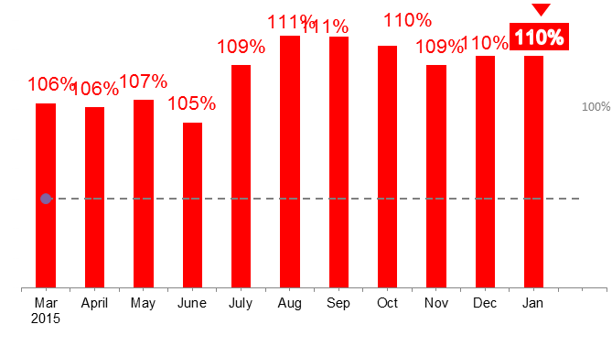

*Book Perimeter: Balance Sheet Management*

*Risk Type: Liquidity Risk*

*Risk Metric: Liquidity Coverage Ratio (LCR)*

|  |  |
| --- | --- |
| **Owner** | ALCO (delegated on Treasury) |
| **1st Line of Defense Area** | **Treasury Department**  Responsibility: Management and strategy implementation |
| **2nd Line of Defense Area** | **Market Risk Department**  Responsibility: Official Report |
| **Description** | *The LCR is a short term metric that requires a banking organization’s stock of unencumbered high-quality liquid assets (HQLAs) to be a specific level over its total net cash outflows over a 30-day standardized supervisory liquidity stress scenario* |
| **Purpose** | *The LCR is a good metric for monitoring short term liquidity under stress situations during a time horizon of 30 days.*  *This metric looks for mitigating shortfalls derived from specific situations related to the level of high liquid assets and stable funding available.*  *The purpose of the metric then is to promote keeping enough high liquid assets that can sustain net outflows in the next 30 days under stress.* |
| **Limit** | *>= 105.00%* |
| **Limit Justification** | *Regulation defines a progressive limit that will be applied under a specific calendar.*  *Santander determines a more conservative level of 100%. This level represents that point that will determine if Santander has enough high liquid assets that exceeds/equals (>=100%) or not (<100%) net outflows or obligations due in the next 30 days horizon period.*  *More important, this limit sets the adequate level of unencumbered liquid assets that can be converted into cash to meet liquidity needs for a 30 days operation.* |
| **Calculation of the metric** | *LCR = High Quality Liquid Assets*  *Net Cash Outflows*  *(For more definitions, see Basel III LCR and FED LCR)* |
| **Availability** | *20th of every month.* |

SHUSA Consolidated LCR – Historical Data

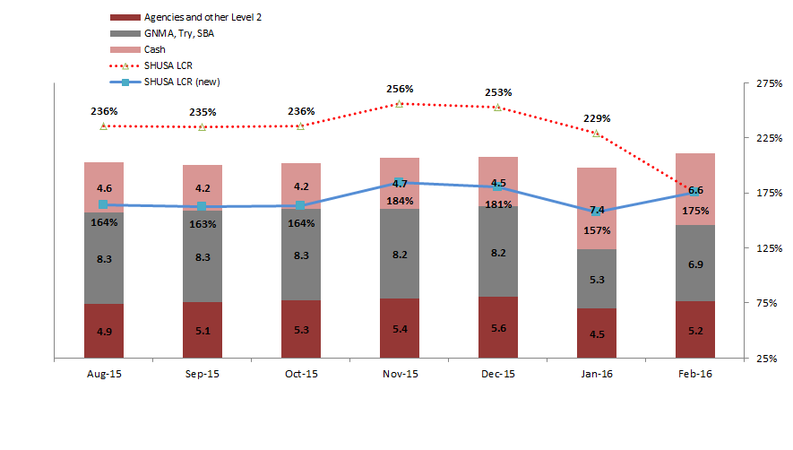

*Book Perimeter: Balance Sheet Management*

*Risk Type: Liquidity Risk*

*Risk Metric: Stress Survival Period*

|  |  |
| --- | --- |
| **Owner** | ALCO (delegated on Treasury) |
| **1st Line of Defense Area** | **Treasury Department**  Responsibility: Management and strategy implementation |
| **2nd Line of Defense Area** | **Market Risk Department**  Responsibility: Official Report |
| **Description** | *This metric measures the number of days the bank has adequate amount of inflows and liquid assets for repayment wholesale outflows.*  *Santander is vigilant on Balance sheet mismatch gap for evaluating the peak days of net cash outflows expected in a specific period of time for attending wholesale funding repayments and anticipating potential shortfalls.*  *This metric measures the worst case of the three scenarios:*  *Idiosyncratic*  *Systemic = Market*  *Local = Combined (Idiosyncratic and Systemic)* |
| **Purpose** | *The* Stress Survival Period *is a good metric for identifying peak days of funding needs.*  *This metric helps to anticipate and mitigate potential shortfalls that the institution can experience under specific scenarios.*  *The purpose of the metric then is proactively managed liquidity for taking actions on those potential shortfalls raised from the stress test results.* |
| **Limit** | *60 days* |
| **Limit Justification** | *The limit level is appropriate once represents a timeframe that anticipate regulatory definitions that usually are set up at 30 days which also can be affected by seasonality.*  *The 30 day period provides a reasonable amount of days that can incorporate business cycle needs, which address the risk that the Holding Company may have substantial contractual inflows late in a 30-day stress period and substantial outflows earlier than 30-day stress period. Adding 15 more days provides a more complete overview of potential mismatches between inflows and outflows, but stresses more the metric having this delays in the inflows. This has been addressed by US Banking institutions in the empirical analysis for the “Peak Day Analysis” presented to the FED for the Liquidity Coverage Ratio (LCR) comment letter.* |
| **Calculation of the metric** |  |
| **Availability** | *A range from 25th to 27h business day of every month, if there is no data and technology issues.*  *The late delivery is explained by the multiple entity process related to the IRR measurement, including SBNA, SC and SHUSA Consolidated portfolios. By the middle of the year is expected that BSI, BSPR and SIS are added to this process. The major constraints relies on SC portfolio reconciliation against GL that happens by the 13 business day of every month, conditioning the time assigned to process, validate, analyze and report the IRR metrics.* |
|  |  |

*Book Perimeter: Balance Sheet Management*

*Risk Type: Liquidity Risk*

*Risk Metric: Asset Encumbrance*

|  |  |
| --- | --- |
| **Owner** | ALCO (delegated on Treasury) |
| **1st Line of Defense Area** | **Treasury Department**  Responsibility: Management and strategy implementation |
| **2nd Line of Defense Area** | **Market Risk Department**  Responsibility: Official Report |
| **Description** | *This metric measures the appetite on secured funding which impact on the amount of assets that remains in ownership of a third party.* |
| **Purpose** | *This metric mitigate the lack of available and additional source of funding under more stress conditions.*  *The purpose of the metric is for limit the dependency on collateralized borrowing, leading to rising bank asset encumbrance levels.* |
| **Limit** | *55%* |
| **Limit Justification** | *The limit level is appropriate once considers the nature of the activity of the subsidiaries of SHUSA. In one side, Santander Bank has an important amount of HQLA that must be kept available to increase the buffer, but at the same time there is an amount of assets that can be pledged to FHLB and do not count as part of the buffer. In other side, Santander Consumer mostly uses secured funding, which will add necessarily almost the total amount of assets of SC into the ratio as full pledged amount, which could add at least the 25%.* |
| **Calculation of the metric** | *AE% = Total Encumbered Assets + Total Collateral Received re-used*  *Total Assets + Total Collateral Received Available for Encumbrance*  *This metric follows the standards defined by Basel Committee and the European Banking Authority.* |
| **Availability** | *20th every month.* |

*Book Perimeter: Balance Sheet Management*

*Risk Type: Liquidity Risk*

*Risk Metric: Loan to Deposit Ratio*

|  |  |
| --- | --- |
| **Owner** | ALCO (delegated on Treasury) |
| **1st Line of Defense Area** | **Treasury Department**  Responsibility: Management and strategy implementation |
| **2nd Line of Defense Area** | **Market Risk Department**  Responsibility: Official Report |
| **Description** | *This metric measures the level of loans funded by customer deposits.* |
| **Purpose** | *This metric ensure a minimum amount of the loan portfolio to be funded by the same type of customers that are related to the nature of the commercial and retail banking activity.*  *The purpose of the metric is limiting the utilization of source of funds not related to the commercial and retail activity to growth on loans generation.* |
| **Limit** | *90%* |
| **Limit Justification** | *The limit level is appropriate once recognize the fundamental nature of the Commercial and Retail Banking activity, which is intermediate between depositors and lenders, and profiting through the service of each type of customers and the difference related to interest rates applied to them.*  *The RAS level then is justified in this core objective, applying a level that creates incentives to self-fund the business.* |
| **Calculation of the metric** | *LTD = Total Deposits*  *Total Loans* |
| **Availability** | *20th every month.* |

*Book Perimeter: Balance Sheet Management*

*Risk Type: Liquidity Risk*

*Risk Metric: Santander Consumer - Available Committed Liquidity (ACL)*

|  |  |
| --- | --- |
| **Owner** | ALCO (delegated on Treasury) |
| **1st Line of Defense Area** | **Treasury Department**  Responsibility: Management and strategy implementation |
| **2nd Line of Defense Area** | **Market Risk Department**  Responsibility: Official Report |
| **Description** | *This metric determines the number of months that Santander Consumer can fund new originations with available committed lines.* |
| **Purpose** | *This RAS determines a minimum number of months that Santander Consumer uncommitted lines must fund their new originations. The purpose of the metric is reducing the impact of new originations volatility over the liquidity position of Santander Consumer by keeping available uncommitted facilities that can satisfy a production period of six months.* |
| **Limit** | *6 months* |
| **Limit Justification** | *The limit level is appropriate because defines a period to plan in case of shortfalls to cover new business originations. This metric replaces the use of the Liquidity Stress Test Survival horizon and at the same time obliges SC to look forward on new business events.* |
| **Calculation of the metric** | *LTD = Total Commitments*  *Net Projected Originations (next 6 months)*  **Net Projected Originations:**  + Projected Originations  + Less: Subvention/Discounts/Participation  + Less: Flow Agreement Commitments  (-) Less: Paydowns    **Total Commitments:**  + External Warehouse Capacity  + Available Remaining BSNY Commitment (Total) |
| **Availability** | *20th every month.* |

1. LIMITS LEVELS RATIONALE SUPPORT
   1. Interest Rate Risk (IRR)

The IRR limits are set from a long term and short term perspective. The short term exposure is mostly measured through one year NII sensitivity over parallel interest rate shocks. Meanwhile, the long term exposure is monitored through the full revaluation of the balance sheet to determine the interest rate impact over the economic value of the equity.

This document is to provide a ***fundamental support for the definition of the new Risk Appetite Statements for SHUSA Consolidated***, including SBNA and SC, based on maximum exposures calculated using P18 strategic plan with both constant rates and implied forward rates in QRM. In addition, SHUSA also provided additional stressed scenarios to calculate maximum exposure. These scenarios include stressed prepayment speeds and NMD beta. SHUSA also accounted for exposure changes due to known model changes that are in the pipeline. These model changes include NMD methodology change as well as ADCo version change. The final Risk Appetite is based on the above factors and considerations related to ***forward looking projections and stress conditions***. The following formula summarizes the calculation method.

Adjusted Mx Exposure = QRM calculated maximum exposure + stressed prepay scenario + stressed beta scenario + NMD model change impact + ADCo model change impact

Below table exhibits the calculated results that lead to Adjusted Limit which is then used as a baseline to determine the Proposed Limit.



* + 1. Market Value of Equity (MVE) – Core Metric

Based on projected maximum SHUSA MVE exposure, SHUSA is proposing a change of MVE Dn 100 operating limit from -$650mm to -$1,100mm. The proposal is based on forecasted worst MVE exposure of -$777mm using constant yield curves as of 8/31/2015. To account for possible stressed environments in the coming months, SHUSA added an additional -$162mm to include possible 50% increase in prepayment speeds. Furthermore, SHUSA is also planning on changing to the recently approved new NMD and ADCo models. Based on Model Control UAT test, the new NMD model will add an additional -$250mm to Dn 100 MVE exposure while new ADCO model will improve the exposure by $160mm. SHUSA concluded an adjusted limit of $-1,029mm and is proposing a new operating limit of -$1,100mm.

Once the limit is set for UP100 and DN100 scenarios, we apply the exposure proportionally based on the amount of shocks. For Up 200 and Up300 shock scenarios, we decide to keep the limits at the level the same as last year even though the adjusted limits are much lower than those in last year since we want to have some cushion for us for all the modeling change and IHC integration in 2016.

The exposure for SHUSA is the sum of the maximum exposure of SBNA, SC and Parent only. The tables below present the exposure at future quarter end for each entity.

**Constant Rates Maximum Exposure - SBNA**



**Constant Rates Maximum Exposure – SC**

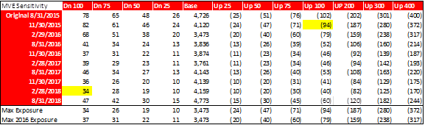

**Maximum Exposure – Parent-Only**



The actual MVE exposure using the Up 200/Down 100 metric for the total of SHUSA Parent plus SBNA plus SCUSA is shown in the graph below. The highest exposure in 2015 was –$716 mm in September 2015.

* + 1. Net Interest Income (NII) – Core Metric

Based on projected maximum SHUSA NII exposure, adjusted NII Dn 100 exposure was -$274mm.

The actual NII exposure using the Up 100/Down 100 metric for the total of SHUSA Parent plus SBNA plus SCUSA is shown in the graph below. The highest exposure in 2015 was –$135 mm in April 2015.

* + 1. Expected Market Conditions

The Strategic Plan was built and modeled with implied forward curves from QRM and constant rates as of August 2015. Below are the expected rate level used in the projection. For constant rates, curves will remain flat as of August 2015.

LIBOR

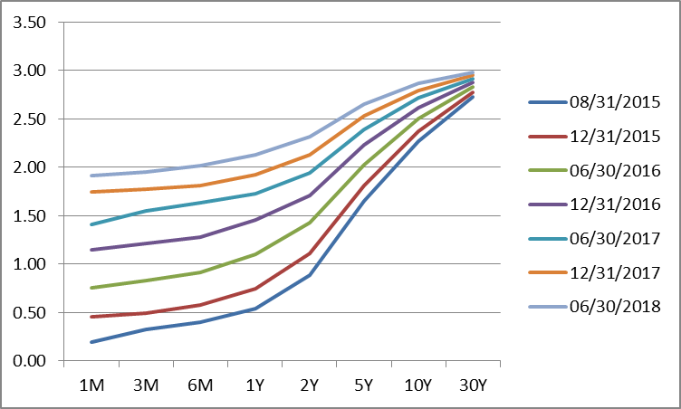

Treasury

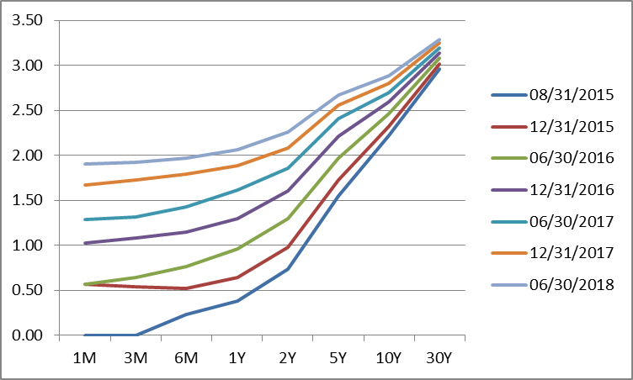

* The table above represents our best estimate of the exposures embedded in the strategic plan. However the accuracy of these estimates depend on a number of model assumptions that add to the uncertainty around sensitivity. Stress testing of key model assumptions shows the following impacts on exposures to DownShocks:
* Spread tightening (-50%) would increase exposure by -$100 mm
* Flattening of the yield curve (stable short term rates and a decrease of 50 bps in the 2-10Yr spread) would decrease NII $30 mm.
* A 50% increase in deposit Betas would increase sensitivity in the down shocks by $ 60 mm.

A +10% increase in stable balances would increase (negative) exposure in the down 100 by $35 mm.

* + 1. SHUSA P18 Balance Projections

SHUSA- P18 Balance changes with respect to August 2015 position



SHUSA – P18 Actual Balances



* 1. Liquidity Risk (LR)
     1. Liquidity Coverage Ratio

LCR is projected to be trending down due to a flattening of HQLA and increased deposit outflow. Volatility in LCR is observed during 1Q-2016, a period of overlap where FHLB advances are replaced with Senior Debt and runoff of existing deposits.

The following is a summary of the LCR calculations of SHUSA and SBNA where HQLA levels and cash flows balances are noted for each unit, as well as the corresponding LCR estimates, all based on the Strategic Plan (P-18) projections:



The following graph presents the historical figures for LCR for SHUSA and SBNA and the corresponding projected LCR estimates:

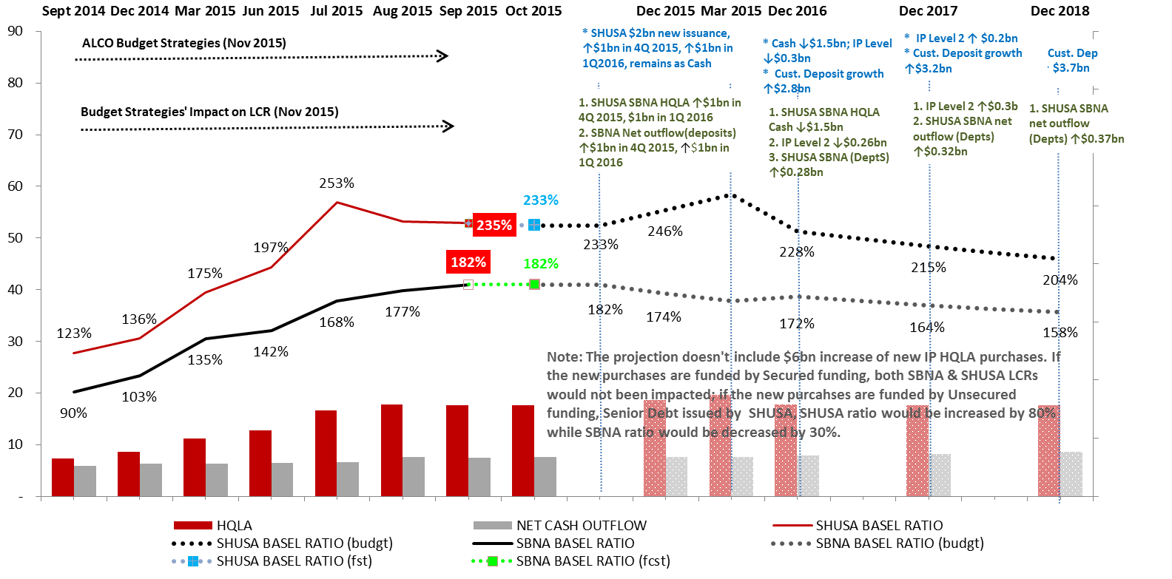

It should be noted that the above forecasts do not include projections on the deviation to the Strategic Plan (P-18) whereby $6bn of new purchase of Investment Portfolio (“IP”) assets would be considered. If $6bn of new IP assets were purchased over the course of 2016, there would be minimal impact on the LCR metric for both units if these purchases were funded with FHLB advances. However, if the new purchases were funded with funding is unsecured (i.e. a senior debt issuance by SHUSA), the SHUSA ratio would increase by 80% while the SBNA ratio would decrease by 30%.

As such, the proposal for the LCR limit for SHUSA would increase to 127% from 100%. Similarly, the proposal for the LCR limit for SBNA would increase by 20% to 110%.

Structural Funding Ratio

Based upon forecasts included in the Strategic Plan, the SBNA SFR ratio trends relatively flat in 2016. The SFR ratio equals 122% in 3Q-2015 and is projected to end 2016 at 120% given said forecast.

The following graph presents the historical figures for LCR for SHUSA and SBNA and the corresponding projected LCR estimates:

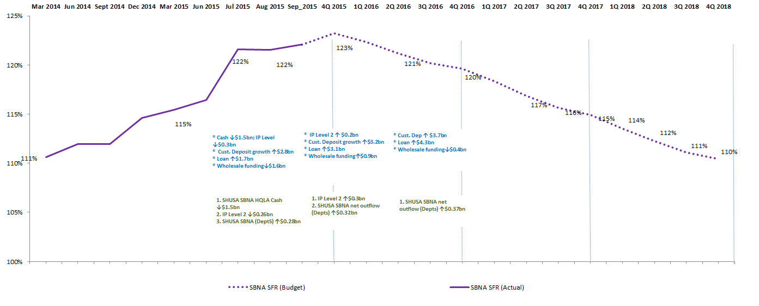

The wholesale funding position in 2015 is concentrated in FHLB advances. The Strategic Plan indicates that the changes in the wholesale funding position will net during 2016 – 2018 while there is modest growth in the loan portfolio. As such, the SFR ratio trends down to 110% at the end of 2018 from 120% range in 2016.

The following graph depicts the changes in the SFR ratio and corresponding change in structural needs versus structural funding:

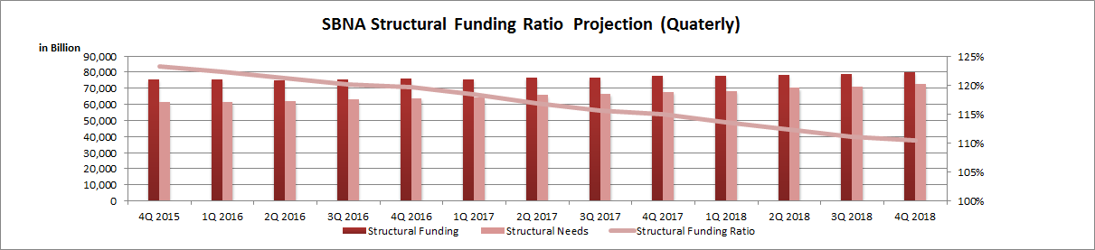

The SCUSA SFR ratio trends flat based upon the Strategic Plan (P-18) of the unit as evidenced by the following graph:

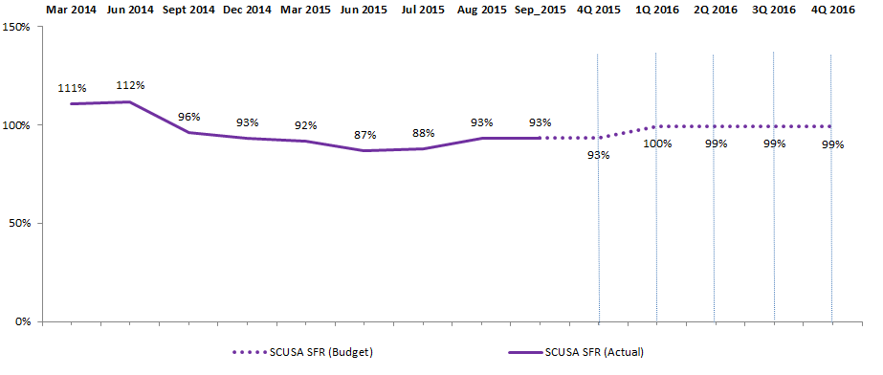

The metric represents the percentage of structural assets that are funded with medium and long term liabilities. The above projections assume warehouse balances always expire greater than a year.

Structural funding needs (assets) include retail loans, structural intragroup funding (not considering contractual maturity), required reserves, fixed assets, intangible asset and other assets.

Structural funding (liabilities) includes medium/long term funding (i.e. warehouse lines, unsecured issuances, securitizations sold in the market and equity).

The measurement ensures that SCUSA is not overly reliant on short-term financing.

Due to the unique nature of the SCUSA balance sheet, the limit proposal is based on SCUSA’s funding profile and verified against historical trends.

As such, the 2016 Proposed Limit for SC is 70%, equivalent to its 2015 level, and the 2016 Proposed Limit for SHUSA equals 102%.

* + 1. Stressed Survival Horizon

Liquidity Stress Testing Survival Horizon (Consolidated – Market, Idiosyncratic and Combined Scenarios):

Purpose of the Limit: The Liquidity Stress Testing Survival Horizon is designed to measure the amount of days remaining until SHUSA and its subsidiaries will have a cash shortfall under Market, Idiosyncratic and Combined stressed conditions. The Liquidity Stress Testing Survival Horizon limit and target are measured in accordance with the firm’s risk appetite.

Limit Calculation: In calculating the net cash outflow need, SHUSA considers the following factors:

* Contractual maturity of assets and liabilities
* Behavioral factors influencing the timing of cash outflows in BAU
* Potential volume and speed of cash outflows by product type under various stress scenarios.

The SHUSA liquidity stress test survival Risk Appetite Statement limit is 60 days. However, SHUSA manages to a target threshold of peak outflow within the 90 days. SHUSA considers 90 days a reasonable liquidity stress test survival horizon as:

* It represents the most acute period of the SHUSA liquidity stressed cash outflows;
* It provides a management buffer to mitigate against potential cliff events that could impact the regulatory minimum period of 1 month;
* It provides the timeline necessary to evaluate, prioritize and execute the more material Contingency Funding Plan (“CFP”) actions; and
* 90 days is aligned with the analysis period that Santander S.A. uses to evaluate the run off of its deposits under stress.

Importantly, while longer time horizons are evaluated under the LST and CFP, the 90 day survival horizon indicates that SHUSA will maintain a liquidity buffer as its primary assurance that it can withstand a liquidity crisis at a minimum for the duration of the defined 90 day period.

As such, the 2016 Proposed Operating Limit for the Unit is a 90-day stressed survival horizon under the worst-case of the aforementioned scenarios, in line with the Risk Appetite Statement metric.

A summary of the Risk Appetite Statement metrics are as follows:



**1. Liquidity Risk Additional Support**

**SHUSA Risk Appetite Statement (“RAS”) metrics – Liquidity Risk**

The following are the metrics that have been selected as RAS limits for 2016:

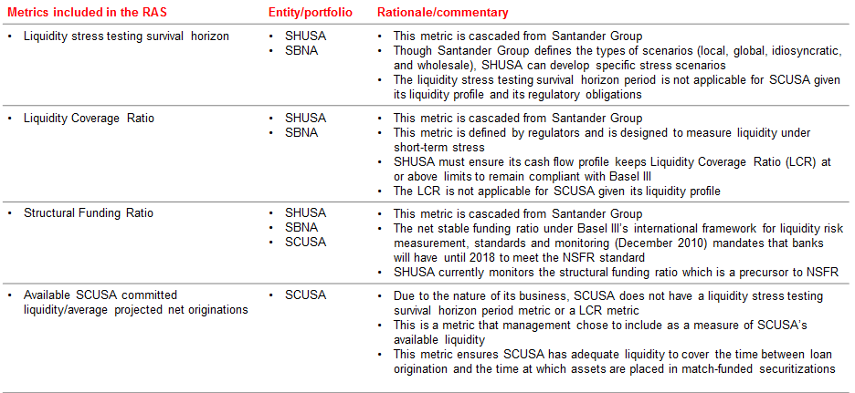

The approach for calibrating the RAS limit thresholds for LCR and SFR limits is as follows:

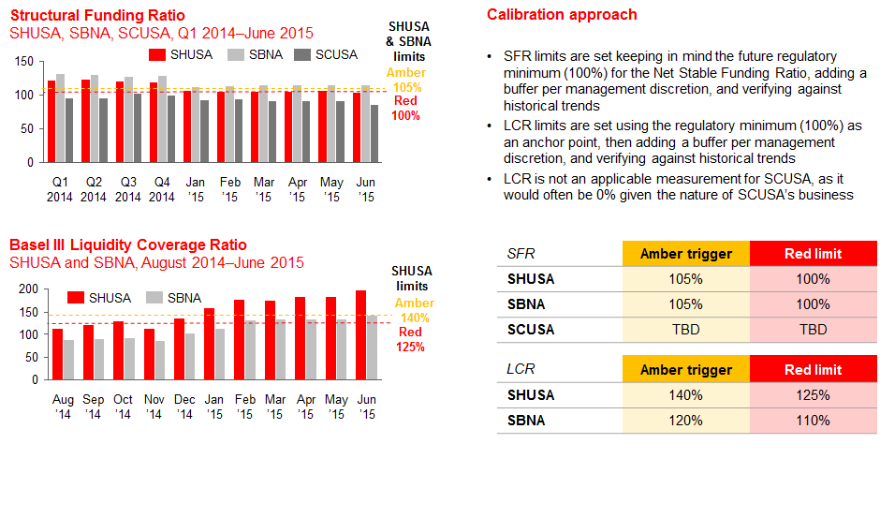

The Liquidity Stress-test Survival Horizon metric measures the amount of days remaining until SHUSA and its subsidiaries will have a cash shortfall under Market, Idiosyncratic and Combined stressed conditions. The Liquidity Stress Testing Survival Horizon limit and target are measured in accordance with the firm’s risk appetite.

The red limit and amber trigger represent a timeframe that is more conservative than the regulatory definition of 30 days.

The 90 day and 60 day amber trigger and red limit provide a more complete overview of potential mismatches between inflows and outflows.

A graphical representation of the historical levels used to determine the RAS limit and threshold at the time of calibration is as follows:

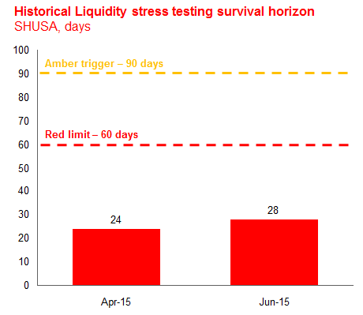

The SCUSA Available Committed Liquidity over Monthly Funding Needs metric, measured in number of months, was considered due to the nature of its business as SCUSA does not have a liquidity stress testing survival horizon metric or an LCR metric.

This metric was designed by management and ensures SCUSA has adequate liquidity to cover the time between loan origination and the time at which assets are placed in match-funded securitizations.

The red limit of 5 months was established by evaluating the changes to the level of the metric if monthly funding needs increase to $1,250 MM or greater without an increase in available liquidity; it is reasonable that the red limit is just above the level of 4.9 months outlined in this scenario.

The amber trigger of 6 months was established by evaluating the changes to the level of the metric if monthly funding needs increase to $1,000 MM and available liquidity decreases by $500 MM; it is reasonable that the amber trigger is just above the level of 5.6 months outlined in this scenario.

The following is graphical representation of historical levels which provided additional insight into limit and threshold calibration:

